MED D - Determining TrOOP Status

Overview
TrOOP and Formulary
PeopleSafe TrOOP Screens - Account Balance
PeopleSafe TrOOP Screens - View Client Financials
Claims Paid between Two Different Levels of Drug Coverage (Formerly Known as Cusp Claims)
Viewing TrOOP Balance Transfer in PeopleSafe
GAP Talking Points FAQ’s – 2024 Plan Year
Log Activity
Exceptions
Related Documents

Description: This document will assist the MED D Customer Care Representative (CCR) in answering a MED D beneficiary’s questions regarding the Medicare Part D TrOOP (True Out of Pocket).

Overview

MED D TrOOP consists of beneficiary’s out of pocket cost during the following stages:
- Stage I: Deductible
- Stage II: Initial Coverage Stage (Copay/Coinsurance)
- Stage III: Coverage Gap Coinsurance (Donut Hole) or Post Initial Coverage for beneficiaries who qualify for LIS.

Refer to MED D – Stages of Medicare Part D Coverage (Deductible, ICL, Coverage Gap, Catastrophic).

Each claim processed for the beneficiary will affect their TrOOP.

Note: TrOOP and its different levels will vary by client and plan.
- Refer to the appropriate CIF for specific client/plan TrOOP details.

To increase efficiency and accuracy when answering the MED D beneficiary’s inquiries regarding his/her TrOOP.

Top of the Document

TrOOP and Formulary

All paid claims for covered prescriptions will affect the MED D beneficiary’s TrOOP. Therefore, it is important to understand that there are a number of drugs that are NOT covered by MED D.

If the beneficiary chooses to purchase medications not covered by the plan, he/she is responsible for the entire out of pocket cost and these monies will NOT accumulate toward their MED D TrOOP.

Review drug coverage in PeopleSafe (test claim).

The beneficiary can also log into their client-specific website (if available) and check the formulary as well.

Top of the Document

PeopleSafe TrOOP Screens - Account Balance

Medicare Part D sponsors (client) are responsible for tracking the beneficiary’s TrOOP.
Follow the steps below to view the beneficiary’s TrOOP status under the Account Balance screen:

Step | Action
1 | Access the Account Balance Screen.
2 | Under the Account Balance Summary, use the following Account Classes to determine the beneficiary’s TrOOP status  - Deductible: Stage I - Beneficiary pays total drug cost until Limit Amount indicated is reached.  - Drug Spend: Stage II - Beneficiary pays copay/coinsurance until Limit Amount indicated is reached.  - Catastrophic Coverage - Stage III - Beneficiaries will pay:
2 | 2025 | 2024
2 | Part D Drugs:  $0 member cost-share  Covered Non-Part D Drugs:  Cost share same as Initial Coverage Limit (Stage II) | Part D Drugs:  $0 member cost-share  Covered Non-Part D Drugs:  Cost share same as Initial Coverage Limit (Stage II)
2 | 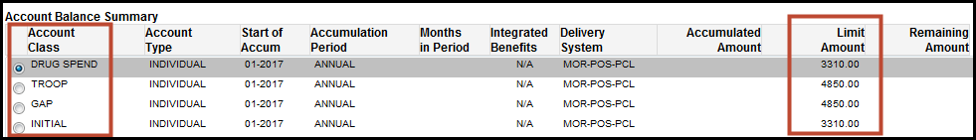  Note: TrOOP and its different levels will vary by client and plan. Refer to the appropriate CIF for specific client/plan TrOOP details.
3 | For more information on a desired TrOOP level, select its radio button and click on View Amounts by Month or View Balance Details buttons (at the bottom of the screen).  Note: Under the Account Balance screen, the availability of these functions will vary by client and adjudication platforms (QL, RECAP and RxClaim).
4 | Locate the claim(s) or Rx#(s) in question and click on the Details link of the claim.  Result: Details pop-up screen displays the claim amount(s) that apply towards their MED D deductible, drug spend or TrOOP.  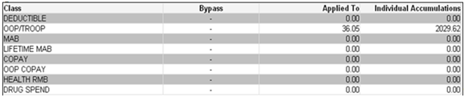

Top of the Document

PeopleSafe TrOOP Screens - View Client Financials

Follow the steps below to view the specific TrOOP claims information under the View Client Financials screen.

Step | Action
1 | Locate the claim(s) or Rx#(s) in question.
2 | From the RX Details screen, click on View Client Financials button.
3 | Under the Participant Pay column, use these four fields to determine TrOOP status.  - Deductible: Stage I - Beneficiary pays drug cost.  - Initial Copay: Stage II - 1st time Beneficiary pays a copay.  - Gap Copay: Stage III - Gap Coverage or Post Initial Phase.  - Catastrophic Copay: Stage IV - Catastrophic Coverage.  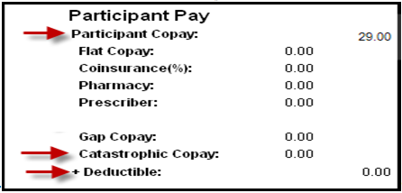
4 | Under the Client Pay column, use these two additional fields to determine TrOOP status.  - LICS paid by plan: This is internal financial information that is not to be discussed with the beneficiary.  - Applied to TrOOP: This is the amount applied to the beneficiary’s TrOOP.  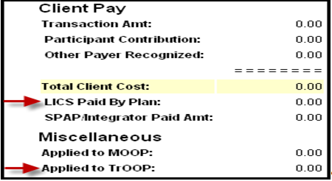

Top of the Document

Claims Paid between Two Different Levels of Drug Coverage (Formerly Known as Cusp Claims)

Beneficiary drug claims that are paid between two different stages of drug coverage because the claim causes a beneficiary not only to meet, but also to exceed a benefit level threshold amount which moves them into the next stage of coverage.

In order to identify and explain to the beneficiary, follow the steps listed below:

Step | Action
1 | Locate the claim/Rx# in question and click on Rx#.  Result: Displays the Prescription Details screen.
2 | Click on the View Financials button.  Result: Displays the View Financials screen.
3 | Review the following fields in the Participant Pay column.  - Initial/Gap Copay  - Catastrophic Copay  - Deductible

If the beneficiary has additional questions, refer to MED D - Explaining and Calculating Claims Example 1 and MED D - Explaining and Calculating Claims Example 2 to determine how the copay was calculated.

The beneficiary has completed Stage I (Deductible) and entered Stage 2 (Initial Coverage Limit/Drug Spend).
- The beneficiary was charged a total amount of $14.00 (Participant Copay field).
The total amount consists of:
    - The remainder of the Deductible being met (Deductible $8.82) and
    - The copay being charged (Initial/Gap copay $5.18).

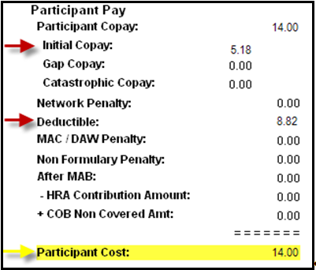
Figure A

Top of the Document

Viewing TrOOP Balance Transfer in PeopleSafe

When a beneficiary changes their MED D plan during the plan year, the two MED D plans will communicate with each other, via the TrOOP Facilitator regarding the beneficiary’s TrOOP balance.

Example: If the beneficiary changes from a MEDDCO MED D plan to SilverScript, the TrOOP Facilitator sends beneficiary’s TrOOP level information to the prior plan and the new plan to ensure TrOOP is appropriately transferred to the new plan.

Note: Beneficiaries will need to contact their new plan regarding their TrOOP accumulations if they have any questions.

This document is meant to assist in identifying transactions which represent a TrOOP Balance transfer from one MED D plan to another MED D plan and how to address issues associated with these transactions.

When receiving a call from the beneficiary regarding his/her TrOOP Balance Transfer, perform the following steps below:
Step | Action
1 | From the Main screen, click on the Account Balance tab.  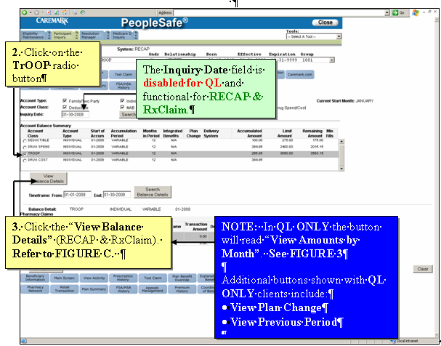  Result: Account Balance Screen displays.
2 | Click the TrOOP radio button.
3 | Click the View Balance Details button (RECAP & RxClaim).  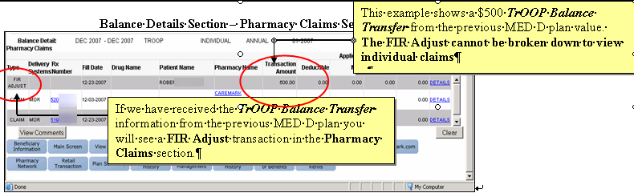  View Amounts by Month Section (QL Only)  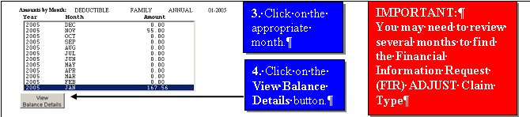  Result: Balance Details Section - Pharmacy Claims section populates.
4 | Provide the Balance Transfer details to the beneficiary.  - If the beneficiary has any dispute regarding the TrOOP Balance Transfer, submit an RMT - Claims Adjustment Task (Deductible/TrOOP Adjustment). Refer to the MED D - Claim Adjustment and Refund Requests work instruction.
5 | Ask if there are any other benefit questions.
5 | If… | Then…
5 | Yes | - Address any benefit issues.  - Document and close the call according to current policies and procedures. Refer to the MED D - Call Documentation Including Viewing and Adding Comments in PeopleSafe work instruction.
5 | No | Document and close the call according to current policies and procedures.  Refer to the MED D - Call Documentation Including Viewing and Adding Comments in PeopleSafe work instruction.

Top of the Document

GAP Talking Points FAQ’s – 2024 Plan Year

The following list of Frequently Asked Questions (FAQs) will assist the CCR with questions from the MED D beneficiary in regard to TrOOP:
Question | Answer
What are the stages to the Medicare Standard Part D prescription drug plan structure? | Medicare Part D plans have four stages of coverage also known as payment stages. The amount the beneficiary pays for a drug depends on which of these stages he/she is in at the time a prescription is filled, the tier level of the drug and the pharmacy used to fill the prescription. Stage one is the yearly Deductible Stage, stage two is the Initial Coverage Stage, stage three is the Coverage Gap Stage (also called the donut hole), and stage four is the Catastrophic Coverage Stage. The Plan informs the beneficiary of these changes annually in the Evidence of Coverage (EOC). Medicare sets the requirements for when a beneficiary moves from one stage to another.  - Deductible Stage: Beneficiary pays full cost of the drug  - Initial Coverage Stage: Beneficiary pays a copay/coinsurance and the plan pays the remainder of the cost until their year-to-date total drug costs reach an amount set by Medicare ($5,030 in 2024 and $4,660 in 2023).  - Coverage Gap Stage (also called the donut hole): Beneficiary pays a 25% coinsurance until their out-of-pocket drug costs reach an amount (also known as TrOOP, true out-of-pocket cost).  - Catastrophic Stage: Beneficiary pays $0 for Part D drugs and copay equal to Initial Coverage Limit coinsurance for covered non-Part D drugs.
Why did I receive a letter about the coverage gap/donut hole? | Access ONEclick or Filenet to determine what letter was sent to the beneficiary.  Refer to MED D - Viewing Correspondence and Requesting Reprints in PeopleSafe and MED D - Filenet work instructions.
What is the coverage gap/donut hole? | Most Medicare drug plans have a Coverage Gap (also called the donut hole). This is the third stage of a Medicare drug plan. This means there's a temporary limit on what the drug plan will cover for drugs during this stage. The Coverage Gap begins after the beneficiary and their drug plan (total cost of the medication) have spent a certain amount for covered drugs. This amount is determined by Medicare and changes every year. Once the beneficiary and their plan have spent $5,030 on covered drugs in 2024 ($4,660 in 2023) they reach the Coverage Gap. Beneficiaries with Medicare who get Extra Help paying Part D costs won’t enter the Coverage Gap. Also some enhanced Medicare drug plans provide benefits during the Coverage Gap stage.  Note: Check CIF as this amount may differ per client.
What happens when I reach the coverage gap/donut hole? | When a beneficiary reaches the Coverage Gap stage, the cost of their medication may change. Depending on the tier of the drug, the cost may increase or decrease during the Coverage Gap stage. During the Coverage Gap stage, the beneficiary will no longer pay the plan’s copay/coinsurance but will pay a Coverage Gap coinsurance (25% for all drugs in 2023). Also, if the beneficiary received a tier exception to lower the cost of their medication, the exception is no longer applied during the Coverage Gap stage because the coinsurance is based on brand versus generic and not the tier level of the drug.
I receive LIS (also known as Extra Help) assistance. How does this affect me? | - Your premiums and co-payments are less and your coverage may also be extended through the coverage gap.  - Therefore, the information in the letter does not apply to you.  - LIS Beneficiaries do not enter a coverage gap, they enter a Post Initial Coverage Phase. Cost will vary depending on the plan and Category level. Refer to:  - MED D - 2024 SilverScript CHOICE LIS Information  - MED D - 2024 SilverScript PLUS LIS Information  - MED D - 2024 SilverScript SMARTSAVER LIS Information  - MED D - 2023 SilverScript CHOICE LIS Information  - MED D - 2023 SilverScript PLUS LIS Information  - MED D - 2023 SilverScript SMARTSAVER LIS Information  - MED D - Blue MedicareRx (NEJE) 2024 AEP Readiness  - MED D - Blue MedicareRx (NEJE) 2023 AEP Readiness  Note: CCRs should ALWAYS check the appropriate CIF to accurately provide premiums and co-payment information. CCRs should reference the LIS Rider sent to the beneficiary with their ANOC.
How can I avoid the gap/donut hole or what help can I receive if I reach the coverage gap? | - Continue to use your ID Card.  - The Coverage Gap represents an actual but temporary gap in your Medicare Part D coverage even though you are still covered by your plan.  - Based on reaching certain dollar amounts you may pay more or less for your drugs while in the gap.  - Usually people reach the gap by taking many medications or a few medications where the cost is high.  - Even if your plan requires you pay more of the drug costs after entering the coverage gap, you would still pay less for your prescriptions than you would without using your prescription coverage ID card.  - Talk to your doctor about using generic or less expensive brand name drugs.  - Your doctor knows about the prescriptions you are currently taking and might consider prescribing a generic medication.  - To delay reaching the coverage gap, ask your doctor if a generic drug or lower-cost brand name drug would work just as well as the one you take now.  - Using generic drugs may also reduce your co-payments/coinsurance.  - Viewing your monthly EOB (Explanation of benefits) statement can also keep you informed of your initial coverage amount remaining. Refer to MED D - Explanation of Benefits (EOB) .  - Ask about mail order if available in your plan.  - Use of mail order may help to reduce costs.  - Mail Order drug prices are normally less expensive than retail.  Note: Medications obtained via mail order will accrue towards the coverage gap.  Reminder: Review the appropriate CIF for Mail Order availability and co-pays.  - Look in to pharmaceutical assistance programs (e.g. patient assistance programs).  - Some pharmaceutical companies offer assistance programs for the drugs they manufacture.  - Visit www.medicare.gov for a list of prescription manufacturers participating in the pharmaceutical assistance program.  - Explore National and Community based charitable programs.  - Some national and community-based charitable programs may have programs that can help you with your drug costs.  - Visit http://www.benefitscheckup.org/  - Contact State Health Insurance Assistance Program (SHIP) in your area for personalized counseling.  - Counseling programs in your area may offer help in finding assistance programs to pay for your medications.  - You can find out more information by contacting your State to see if you qualify for assistance.  CCR Process Note:  Refer to the following documents:  - Medicare and Medicaid SHIP Counselor Unique ID List  - MED D - SHIP Counselor Calls For CVS Caremark Part D Plans  - Apply for Extra Help.  - If you have Medicare and have limited income and resources, you may qualify for Extra Help paying for your prescription drugs.  - In order to find out if you qualify, Contact Social Security by visiting www.socialsecurity.gov or by calling 1-800-772-1213. TTY users should call 1-800-325-0778.
Are there any plans that have 100% coverage in the Gap? | - Most, if not all individual prescription drug plans do not have 100% coverage in the Coverage Gap due to cost.  - You may visit http://www.medicare.gov/or call them at 1-800-633-4227 for more information on individual plans.

Top of the Document

Log Activity

1003 - Plan Design

Top of the Document

Exceptions

TrOOP and its different levels will vary by client and plan.
- Refer to the appropriate CIF for specific client/plan TrOOP details.

Top of the Document

Related Documents

Grievance Standard Verbiage (for use in Discussion with Beneficiary) section in MED D - Grievances Index

Parent SOP: CALL-0048: Medicare Part D Customer Care Call Center Requirements-CVS Caremark Part D Services, L.L.C.
Abbreviations/Definitions: Customer Care Abbreviations, Definitions, and Terms Index

Top of the Document

Not to Be Reproduced or Disclosed to Others without Prior Written Approval
ELECTRONIC DATA = OFFICIAL VERSION - PAPER COPY = INFORMATIONAL ONLY

